LED Characterization

Pei Xian Yang, Suyeon Rhim and Arjun Behl  
PCS 224-102 Liam Kischuck

## Introduction:

The objective of this lab is to determine the Iv characteristics of the six different Leds and to identify the turn on voltage . This lab’s aim is to also find the Planks’ constant by plotting band gap vs frequency.

## Theory:

Light Emitting Diodes are a unique type of pn junction where recombination of carriers results in a photon being emitted.When a voltage equal to the band gap energy is applied across a pn junction, electrons and holes are transferred across the space charge region where they become minority carriers. These minority carriers in the p type or n type regions eventually where they recombine with majority carriers. If this recombination process is a direct band-toband process, photons are emitted. In an Indirect bandgap semiconductor, the top of the valence band and bottom of the conduction band lie at different values of the momentum vector in the energy vs momentum graph . If an electron goes from the top of the valence band to the bottom of the conduction band, it has to change its energy as well momentum. Hence, in indirect transitions, energy is thermally transferred to an acoustic phonon(the collective motion of atoms constituting a crystal) and then to a photon, or occurs through phonon generation alone.

The equation of the diode current is given below.

I = Io …. 1, where I is the current, V is voltage, e is the charge of the electron, T is temperature in kelvins ,Io is the saturation current and Kb is Boltzmann’s constant. Simplifying this equation further we get,

$\frac{I}{Io}+1$ = $e^{\frac{e}{kBT}V}$, taking natural logarithm of equation we get,

$ln(\frac{I}{Io}+1)$ = ${\frac{e}{kBT}V}^{}$ as I>>> Io we can ignore 1

$ln(I)-ln(Io)$ = ${\frac{e}{kBT}V}^{}$……2. Comparing it to equation of line(y= mx +c), we get y = ln(I), c = ln(Io), x = V, m = $\frac{e}{kBT}$, measurement of V and I must be taken.

Energy of the photon is equal to hv = Eg …..3, where v is the frequency, h is the planck's constant, Eg is the energy gap. Furthermore Eg = eVt where Vt is the threshold voltage required for carriers to diffuse across the transition region. Comparing eq 3 to the equation of straight line we get, y = Eg, x = v and h = m. v = $\frac{c}{λ}$, where c is speed of light and $λ$ is wavelength.

**.**

**1**“Turn-on” or threshold voltage refers to the forward voltage of a diode which is the required positive voltage across the diode before it starts to conduct current in the forward direction. It means that once a certain amount of voltage reaches a threshold, the diode turns on and allows current through the diode with required voltages.

The equation of turn-on voltage is below.

$eV_{t}=E_{g}$, where Vt is the turn-on voltage, e is the unit charge of an electron, and Eg is the energe gap.

For a silicon diode, the turn-on voltage is approximately 0.7 volt, for germanium diode it is approximately 0.3 volt. Most common LED’s require a threshold voltage of between approximately 1.2 to 4 volts with a current of 20mA. It varies by the color of the LED. A red LED typically drops around 1.6 to 2 volts, a yellow LED drops around 2.1 to 2.2 volts, a green LED drops 1.9 to 4 volts, a blue LED drops 2.5 to 3.7 volts, and a violet drops 2.8 to 4 volts

## Procedure:

In this lab the following equipment was used: Arduino microcontroller, Adafruit MCP4745 12-bit 5V DAC breakout board, Adafruit INA219 DC High-Side Current Sensor breakout board, MCP6002 dual op-amp (CMOS), 2N3904 BJT transistor,Electrical prototyping board,Jumper wires.

1. Finish the given circuit using jumper wires. Make sure the wires are placed correctly.
2. Place an LED into the circuit.
3. Download the LED_IV.txt file from d2l. Copy and paste the code to the Arduino program to edit.
4. Use a for loop to increase the DAC voltage in small increments
5. Include an instruction in the code to stop if the current exceeds 100 mA.
6. Connect the Arduino board to the computer using the given usb.
7. Upload the program by informing the IDE the type of board(Arduino Mini) is being used. Go to the tools menu and select the board model. The IDE also needs to be informed about the serial port the Arduino board is connected to. Again, go to the tools menu, select Serial Port and then select dev/cu.usbserial-.
8. Make sure to turn off the LED for at least 10 times longer than it was on to allow cooling.
9. Record the data set in a spreadsheet.
10. Repeat steps 1-9 till you get a data set of IV characteristics for each 6 LEDs of different wavelengths.
11. Remove the jumper wires from the circuit and leave the other wires in place.

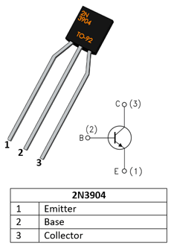 (1)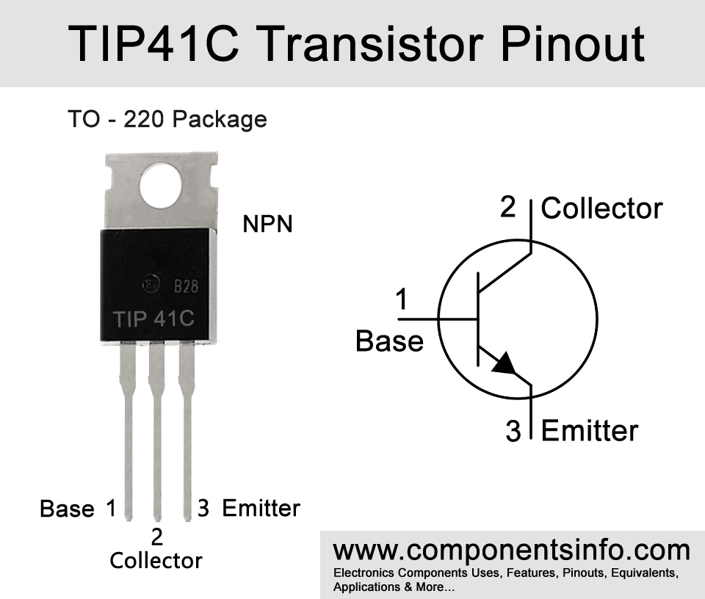(2)

2The first one is a 2N3904 transistor and the second one is a TIP41C transistor. The pin out order of these two transistors is slightly different. Due to this pin out order, the wiring should be changed If we change the transistor 2N3904 to TIP41C, the wire connected to pin 1 of 2N3904 transistor changes to the pin 3 of TIP41C, the wire connected to pin 2 of 2N3904 changes to the pin 1 of TIP41C, and the wire connected to pin 3 of 2N3904 and ground changes to the pin 2 of TIP41C.

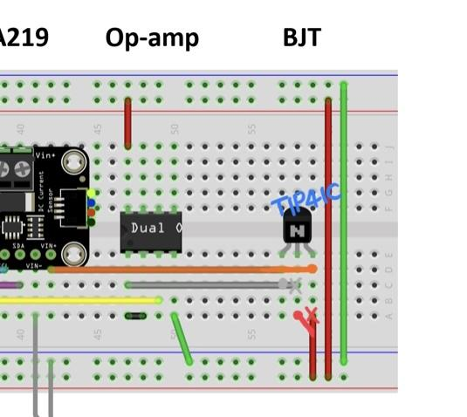

## Results and Calculations:

## 

| Voltage(red) | Current (ma) | ln (A) | v(yellow) | Current (ma) | ln(A) | v(green) | Current (ma) | current (A) | ln i | v(blue) | Current (ma) | current (A) | ln i | v(purple) | Current (ma) | current (A) | ln i | V(IR) | Current (ma) | current (A) | ln i |
| --- | --- | --- | --- | --- | --- | --- | --- | --- | --- | --- | --- | --- | --- | --- | --- | --- | --- | --- | --- | --- | --- |
| 1.03 | 0 |  | 1.02 | 0.1 |  | 1.02 | -0.3 | -0.0003 |  | 1.02 | 0 | 0 |  | 0.76 | 0.2 | 0.0002 |  | 1.03 | 0.1 | 0.0001 |  |
| 1.03 | 0.3 |  | 1.02 | -0.1 |  | 1.02 | -0.1 | -0.0001 |  | 1.03 | 0 | 0 |  | 0.76 | -0.3 | -0.0003 |  | 1.02 | 0.2 | 0.0002 |  |
| 1.03 | 0.3 |  | 1.02 | -0.1 |  | 1.03 | 0.1 | 0.0001 |  | 1.02 | 0.1 | 0.0001 |  | 0.76 | 0.2 | 0.0002 |  | 1.03 | -0.1 | -0.0001 |  |
| 1.02 | -0.1 |  | 1.03 | 0 |  | 1.02 | 0.4 | 0.0004 |  | 1.03 | 0 | 0 |  | 0.76 | 0 | 0 |  | 1.03 | 0.1 | 0.0001 |  |
| 1.03 | 0 |  | 1.03 | -0.1 |  | 1.02 | 0 | 0 |  | 1.02 | 0.1 | 0.0001 |  | 0.76 | 0 | 0 |  | 1.03 | -0.2 | -0.0002 |  |
| 1.03 | 0.1 |  | 1.02 | 0 |  | 1.02 | -0.2 | -0.0002 |  | 1.02 | 0.1 | 0.0001 |  | 0.76 | 0.2 | 0.0002 |  | 1.02 | 0.2 | 0.0002 |  |
| 1.02 | 0.1 |  | 1.03 | 0 |  | 1.03 | -0.1 | -0.0001 |  | 1.03 | 0 | 0 |  | 0.76 | -0.1 | -0.0001 |  | 1.02 | 0 | 0 |  |
| 1.03 | -0.1 |  | 1.03 | 0 |  | 1.03 | -0.1 | -0.0001 |  | 1.03 | 0.2 | 0.0002 |  | 0.76 | 0 | 0 |  | 1.02 | 0 | 0 |  |
| 1.02 | 0.3 |  | 1.03 | -0.1 |  | 1.02 | -0.1 | -0.0001 |  | 1.02 | 0.1 | 0.0001 |  | 0.76 | 0.1 | 0.0001 |  | 1.02 | 0.1 | 0.0001 |  |
| 1.02 | 0.2 |  | 1.02 | 0.2 |  | 1.02 | 0 | 0 |  | 1.03 | -0.2 | -0.0002 |  | 0.76 | 0 | 0 |  | 1.02 | 0 | 0 |  |
| 1.03 | 0 |  | 1.03 | 0.1 |  | 1.03 | 0 | 0 |  | 1.02 | -0.1 | -0.0001 |  | 0.76 | -0.1 | -0.0001 |  | 1.03 | 0.2 | 0.0002 |  |
| 1.02 | 0.2 |  | 1.03 | -0.1 |  | 1.02 | -0.1 | -0.0001 |  | 1.03 | 0 | 0 |  | 0.76 | -0.1 | -0.0001 |  | 1.03 | 0 | 0 |  |
| 1.02 | 0 |  | 1.02 | 0.2 |  | 1.03 | 0 | 0 |  | 1.03 | 0 | 0 |  | 0.76 | 0.2 | 0.0002 |  | 1.02 | 0.2 | 0.0002 |  |
| 1.02 | 0.1 |  | 1.02 | 0.1 |  | 1.02 | -0.2 | -0.0002 |  | 1.03 | 0.3 | 0.0003 |  | 0.76 | 0.4 | 0.0004 |  | 1.03 | 0.1 | 0.0001 |  |
| 1.03 | 0.1 |  | 1.02 | -0.1 |  | 1.03 | 0.3 | 0.0003 |  | 1.02 | -0.1 | -0.0001 |  | 0.76 | 0 | 0 |  | 1.02 | 0 | 0 |  |
| 1.03 | -0.1 |  | 1.03 | 0.2 |  | 1.02 | 0.1 | 0.0001 |  | 1.03 | 0 | 0 |  | 0.76 | 0.2 | 0.0002 |  | 1.02 | 0 | 0 |  |
| 1.03 | 0.2 |  | 1.02 | 0.1 |  | 1.02 | -0.1 | -0.0001 |  | 1.03 | 0.2 | 0.0002 |  | 0.76 | 0 | 0 |  | 1.03 | 0 | 0 |  |
| 1.02 | -0.2 |  | 1.02 | 0.2 |  | 1.02 | -0.3 | -0.0003 |  | 1.02 | 0.2 | 0.0002 |  | 0.76 | 0 | 0 |  | 1.03 | -0.1 | -0.0001 |  |
| 1.02 | 0 |  | 1.02 | -0.1 |  | 1.02 | 0.1 | 0.0001 |  | 1.03 | 0 | 0 |  | 0.76 | 0.2 | 0.0002 |  | 1.02 | 0.1 | 0.0001 |  |
| 1.02 | 0 |  | 1.03 | -0.2 |  | 1.03 | 0.4 | 0.0004 |  | 1.03 | -0.1 | -0.0001 |  | 0.76 | 0 | 0 |  | 1.03 | -0.1 | -0.0001 |  |
| 1.03 | 0.3 |  | 1.02 | 0.2 |  | 1.03 | 0.1 | 0.0001 |  | 1.02 | -0.1 | -0.0001 |  | 0.76 | 0 | 0 |  | 1.02 | 0 | 0 |  |
| 1.02 | 0.2 |  | 1.03 | 0.1 |  | 1.03 | -0.1 | -0.0001 |  | 1.03 | -0.1 | -0.0001 |  | 0.76 | 0.2 | 0.0002 |  | 1.03 | 0.1 | 0.0001 |  |
| 1.02 | 0 |  | 1.02 | -0.2 |  | 1.02 | 0.1 | 0.0001 |  | 1.03 | -0.3 | -0.0003 |  | 0.76 | 0.2 | 0.0002 |  | 1.02 | 0 | 0 |  |
| 1.03 | 0.3 |  | 1.03 | -0.1 |  | 1.03 | 0.3 | 0.0003 |  | 1.02 | -0.1 | -0.0001 |  | 0.76 | 0.2 | 0.0002 |  | 1.02 | -0.1 | -0.0001 |  |
| 1.03 | 0.1 |  | 1.02 | 0.2 |  | 1.03 | 0 | 0 |  | 1.02 | 0.1 | 0.0001 |  | 0.76 | -0.1 | -0.0001 |  | 1.02 | -0.2 | -0.0002 |  |
| 1.03 | -0.1 |  | 1.03 | -0.1 |  | 1.03 | 0 | 0 |  | 1.03 | 0.1 | 0.0001 |  | 0.76 | 0.2 | 0.0002 |  | 1.02 | 0 | 0 |  |
| 1.03 | 0.1 |  | 1.02 | 0.1 |  | 1.02 | 0.2 | 0.0002 |  | 1.02 | -0.1 | -0.0001 |  | 0.76 | 0.1 | 0.0001 |  | 1.03 | 0 | 0 |  |
| 1.03 | 0 |  | 1.03 | 0 |  | 1.02 | -0.2 | -0.0002 |  | 1.02 | 0.3 | 0.0003 |  | 0.76 | 0.1 | 0.0001 |  | 1.03 | -0.1 | -0.0001 |  |
| 1.02 | -0.3 |  | 1.03 | 0 |  | 1.02 | 0 | 0 |  | 1.02 | -0.1 | -0.0001 |  | 0.76 | 0.3 | 0.0003 |  | 1.02 | 0 | 0 |  |
| 1.02 | 0.2 |  | 1.03 | 0.1 |  | 1.02 | 0 | 0 |  | 1.03 | 0 | 0 |  | 0.76 | 0 | 0 |  | 1.03 | 0 | 0 |  |
| 1.03 | 0.2 |  | 1.03 | -0.1 |  | 1.02 | 0.1 | 0.0001 |  | 1.03 | 0 | 0 |  | 0.76 | 0.1 | 0.0001 |  | 1.02 | 0 | 0 |  |
| 1.02 | 0.1 |  | 1.02 | 0 |  | 1.02 | 0 | 0 |  | 1.03 | 0 | 0 |  | 0.76 | 0.1 | 0.0001 |  | 1.02 | -0.1 | -0.0001 |  |
| 1.03 | -0.1 |  | 1.03 | 0.1 |  | 1.02 | 0 | 0 |  | 1.02 | 0.1 | 0.0001 |  | 0.76 | 0.2 | 0.0002 |  | 1.03 | -0.1 | -0.0001 |  |
| 1.03 | -0.1 |  | 1.03 | 0 |  | 1.03 | -0.1 | -0.0001 |  | 1.02 | -0.1 | -0.0001 |  | 0.76 | -0.1 | -0.0001 |  | 1.02 | 0.2 | 0.0002 |  |
| 1.02 | -0.1 |  | 1.03 | 0.2 |  | 1.02 | 0.2 | 0.0002 |  | 1.02 | 0 | 0 |  | 0.76 | 0 | 0 |  | 1.02 | 0 | 0 |  |
| 1.02 | -0.1 |  | 1.02 | 0.2 |  | 1.02 | 0.1 | 0.0001 |  | 1.03 | 0 | 0 |  | 0.76 | -0.3 | -0.0003 |  | 1.02 | -0.1 | -0.0001 |  |
| 1.03 | 0.1 |  | 1.02 | 0 |  | 1.02 | -0.1 | -0.0001 |  | 1.02 | 0.1 | 0.0001 |  | 0.76 | 0.1 | 0.0001 |  | 1.02 | -0.1 | -0.0001 |  |
| 1.02 | 0.1 |  | 1.03 | 0 |  | 1.02 | 0.2 | 0.0002 |  | 1.02 | -0.2 | -0.0002 |  | 0.76 | -0.1 | -0.0001 |  | 1.02 | 0.3 | 0.0003 |  |
| 1.02 | -0.1 |  | 1.02 | 0 |  | 1.03 | 0.3 | 0.0003 |  | 1.02 | 0.1 | 0.0001 |  | 0.76 | 0.1 | 0.0001 |  | 1.03 | 0.1 | 0.0001 |  |
| 1.03 | 0.2 |  | 1.02 | 0.2 |  | 1.02 | 0.2 | 0.0002 |  | 1.02 | 0 | 0 |  | 0.76 | -0.1 | -0.0001 |  | 1.02 | -0.2 | -0.0002 |  |
| 1.03 | -0.1 |  | 1.02 | -0.2 |  | 1.02 | 0.1 | 0.0001 |  | 1.02 | 0.1 | 0.0001 |  | 0.76 | 0.2 | 0.0002 |  | 1.02 | 0 | 0 |  |
| 1.02 | 0.1 |  | 1.03 | 0.2 |  | 1.03 | 0 | 0 |  | 1.02 | -0.1 | -0.0001 |  | 0.76 | 0 | 0 |  | 1.03 | 0 | 0 |  |
| 1.02 | 0.1 |  | 1.02 | -0.2 |  | 1.03 | -0.1 | -0.0001 |  | 1.02 | 0.1 | 0.0001 |  | 0.76 | 0.2 | 0.0002 |  | 1.02 | 0.1 | 0.0001 |  |
| 1.03 | 0.2 |  | 1.02 | 0.2 |  | 1.03 | 0.1 | 0.0001 |  | 1.03 | 0 | 0 |  | 0.76 | -0.1 | -0.0001 |  | 1.03 | 0 | 0 |  |
| 1.03 | 0 |  | 1.02 | 0 |  | 1.03 | -0.1 | -0.0001 |  | 1.03 | 0.1 | 0.0001 |  | 0.76 | 0.5 | 0.0005 |  | 1.02 | 0.1 | 0.0001 |  |
| 1.02 | -0.3 |  | 1.03 | -0.1 |  | 1.03 | 0.2 | 0.0002 |  | 1.02 | -0.1 | -0.0001 |  | 0.76 | 0.1 | 0.0001 |  | 1.03 | 0 | 0 |  |
| 1.02 | 0.1 |  | 1.03 | 0.1 |  | 1.03 | 0 | 0 |  | 1.02 | 0.1 | 0.0001 |  | 0.76 | -0.3 | -0.0003 |  | 1.02 | 0.1 | 0.0001 |  |
| 1.02 | 0.1 |  | 1.03 | -0.1 |  | 1.02 | 0.2 | 0.0002 |  | 1.02 | 0.1 | 0.0001 |  | 0.76 | 0.2 | 0.0002 |  | 1.03 | 0 | 0 |  |
| 1.03 | -0.2 |  | 1.03 | -0.1 |  | 1.02 | 0 | 0 |  | 1.02 | 0 | 0 |  | 0.76 | 0 | 0 |  | 1.02 | -0.2 | -0.0002 |  |
| 1.02 | -0.1 |  | 1.02 | -0.1 |  | 1.02 | 0.1 | 0.0001 |  | 1.03 | 0.2 | 0.0002 |  | 0.76 | 0.1 | 0.0001 |  | 1.03 | 0.2 | 0.0002 |  |
| 1.02 | 0.1 |  | 1.03 | 0 |  | 1.03 | 0.1 | 0.0001 |  | 1.02 | -0.2 | -0.0002 |  | 0.76 | 0.2 | 0.0002 |  | 1.02 | 0.2 | 0.0002 |  |
| 1.02 | 0.1 |  | 1.03 | -0.1 |  | 1.02 | 0 | 0 |  | 1.03 | -0.4 | -0.0004 |  | 0.76 | 0.1 | 0.0001 |  | 1.02 | 0 | 0 |  |
| 1.02 | 0.1 |  | 1.03 | 0 |  | 1.03 | 0.2 | 0.0002 |  | 1.02 | 0 | 0 |  | 0.76 | 0.2 | 0.0002 |  | 1.03 | 0.3 | 0.0003 |  |
| 1.03 | 0 |  | 1.02 | -0.1 |  | 1.02 | 0 | 0 |  | 1.02 | 0 | 0 |  | 0.77 | 0.1 | 0.0001 |  | 1.02 | 0 | 0 |  |
| 1.03 | 0 |  | 1.03 | -0.1 |  | 1.02 | 0.1 | 0.0001 |  | 1.02 | 0.2 | 0.0002 |  | 0.78 | -0.1 | -0.0001 |  | 1.03 | 0.1 | 0.0001 |  |
| 1.02 | 0.1 |  | 1.02 | 0 |  | 1.02 | 0 | 0 |  | 1.02 | -0.2 | -0.0002 |  | 0.79 | 0.1 | 0.0001 |  | 1.02 | 0 | 0 |  |
| 1.03 | 0.1 |  | 1.02 | 0.2 |  | 1.02 | 0 | 0 |  | 1.02 | 0 | 0 |  | 0.8 | 0.1 | 0.0001 |  | 1.03 | -0.1 | -0.0001 |  |
| 1.03 | -0.1 |  | 1.02 | -0.1 |  | 1.02 | -0.1 | -0.0001 |  | 1.02 | -0.1 | -0.0001 |  | 0.82 | 0.1 | 0.0001 |  | 1.02 | -0.1 | -0.0001 |  |
| 1.03 | 0.1 |  | 1.02 | -0.1 |  | 1.03 | 0.1 | 0.0001 |  | 1.03 | 0.3 | 0.0003 |  | 0.83 | -0.1 | -0.0001 |  | 1.02 | 0.2 | 0.0002 |  |
| 1.03 | -0.3 |  | 1.03 | 0.2 |  | 1.03 | 0 | 0 |  | 1.03 | -0.2 | -0.0002 |  | 0.84 | 0 | 0 |  | 1.03 | 0 | 0 |  |
| 1.03 | 0 |  | 1.02 | 0 |  | 1.03 | 0.2 | 0.0002 |  | 1.03 | 0.1 | 0.0001 |  | 0.85 | 0.1 | 0.0001 |  | 1.03 | 0.1 | 0.0001 |  |
| 1.03 | -0.2 |  | 1.03 | 0 |  | 1.03 | 0.1 | 0.0001 |  | 1.03 | 0 | 0 |  | 0.87 | 0.1 | 0.0001 |  | 1.03 | 0.1 | 0.0001 |  |
| 1.04 | 0.2 |  | 1.04 | -0.1 |  | 1.04 | -0.1 | -0.0001 |  | 1.04 | -0.1 | -0.0001 |  | 0.89 | 0.1 | 0.0001 |  | 1.03 | 0 | 0 |  |
| 1.06 | 0.2 |  | 1.04 | 0 |  | 1.04 | 0.3 | 0.0003 |  | 1.04 | 0 | 0 |  | 0.9 | -0.2 | -0.0002 |  | 1.04 | -0.4 | -0.0004 |  |
| 1.06 | 0.2 |  | 1.06 | 0.1 |  | 1.05 | -0.1 | -0.0001 |  | 1.05 | -0.2 | -0.0002 |  | 0.92 | -0.1 | -0.0001 |  | 1.05 | -0.1 | -0.0001 |  |
| 1.08 | 0.1 |  | 1.06 | 0.1 |  | 1.06 | -0.1 | -0.0001 |  | 1.06 | 0.1 | 0.0001 |  | 0.94 | -0.1 | -0.0001 |  | 1.06 | -0.3 | -0.0003 |  |
| 1.09 | -0.1 |  | 1.08 | 0.3 |  | 1.08 | 0 | 0 |  | 1.08 | 0 | 0 |  | 0.95 | 0.1 | 0.0001 | -9.210340372 | 1.08 | 0.1 | 0.0001 |  |
| 1.11 | -0.2 |  | 1.09 | 0 |  | 1.09 | -0.1 | -0.0001 |  | 1.09 | 0 | 0 |  | 0.96 | 0.2 | 0.0002 | -8.517193191 | 1.09 | 0 | 0 |  |
| 1.13 | -0.2 |  | 1.11 | 0 |  | 1.11 | -0.2 | -0.0002 |  | 1.11 | -0.1 | -0.0001 |  | 0.98 | 0.2 | 0.0002 | -8.517193191 | 1.11 | -0.1 | -0.0001 |  |
| 1.15 | 0.1 |  | 1.13 | 0 |  | 1.13 | -0.1 | -0.0001 |  | 1.13 | -0.2 | -0.0002 |  | 1 | 0.4 | 0.0004 | -7.824046011 | 1.13 | 0.3 | 0.0003 |  |
| 1.17 | 0.1 |  | 1.16 | 0.1 |  | 1.15 | -0.1 | -0.0001 |  | 1.16 | -0.1 | -0.0001 |  | 1.01 | 0.7 | 0.0007 | -7.264430223 | 1.16 | 0.3 | 0.0003 |  |
| 1.19 | -0.2 |  | 1.18 | 0.2 |  | 1.17 | -0.1 | -0.0001 |  | 1.17 | -0.1 | -0.0001 |  | 1.03 | 1.2 | 0.0012 | -6.725433722 | 1.17 | 0 | 0 |  |
| 1.2 | 0.2 |  | 1.19 | 0.1 |  | 1.19 | 0.1 | 0.0001 |  | 1.19 | 0 | 0 |  | 1.04 | 1 | 0.001 | -6.907755279 | 1.19 | 0.1 | 0.0001 |  |
| 1.23 | -0.1 |  | 1.21 | 0.1 |  | 1.2 | 0.1 | 0.0001 |  | 1.21 | 0.2 | 0.0002 |  | 1.06 | 1.6 | 0.0016 | -6.43775165 | 1.2 | -0.2 | -0.0002 |  |
| 1.25 | 0 |  | 1.23 | 0.2 |  | 1.23 | 0.2 | 0.0002 |  | 1.23 | 0 | 0 |  | 1.07 | 2.2 | 0.0022 | -6.119297919 | 1.23 | 0.3 | 0.0003 |  |
| 1.28 | 0 |  | 1.26 | 0 |  | 1.25 | 0 | 0 |  | 1.26 | 0.1 | 0.0001 |  | 1.08 | 3 | 0.003 | -5.80914299 | 1.25 | -0.1 | -0.0001 |  |
| 1.31 | 0 |  | 1.28 | 0.1 |  | 1.28 | -0.1 | -0.0001 |  | 1.28 | 0.1 | 0.0001 |  | 1.1 | 4.2 | 0.0042 | -5.472670754 | 1.28 | 0 | 0 |  |
| 1.32 | -0.1 |  | 1.31 | 0 |  | 1.31 | -0.2 | -0.0002 |  | 1.31 | 0.2 | 0.0002 |  | 1.11 | 5.6 | 0.0056 | -5.184988681 | 1.3 | 0.2 | 0.0002 |  |
| 1.35 | 0.4 |  | 1.33 | -0.2 |  | 1.32 | 0 | 0 |  | 1.32 | 0 | 0 |  | 1.12 | 7 | 0.007 | -4.96184513 | 1.32 | 0.2 | 0.0002 |  |
| 1.36 | 0.2 |  | 1.35 | -0.1 |  | 1.35 | 0 | 0 |  | 1.35 | -0.1 | -0.0001 |  | 1.14 | 8.8 | 0.0088 | -4.733003557 | 1.35 | 0 | 0 |  |
| 1.39 | 0.2 |  | 1.36 | 0 |  | 1.36 | 0.1 | 0.0001 |  | 1.37 | 0.2 | 0.0002 |  | 1.15 | 10.3 | 0.0103 | -4.575611384 | 1.36 | 0.1 | 0.0001 |  |
| 1.42 | 0.2 |  | 1.39 | 0 |  | 1.39 | -0.2 | -0.0002 |  | 1.39 | -0.1 | -0.0001 |  | 1.16 | 12.9 | 0.0129 | -4.350527968 | 1.39 | 0.1 | 0.0001 |  |
| 1.44 | 0 |  | 1.42 | 0.1 |  | 1.42 | 0.2 | 0.0002 |  | 1.42 | 0.1 | 0.0001 |  | 1.18 | 16.1 | 0.0161 | -4.128936007 | 1.42 | -0.2 | -0.0002 |  |
| 1.46 | 0.2 |  | 1.44 | -0.1 |  | 1.45 | -0.1 | -0.0001 |  | 1.45 | 0 | 0 |  | 1.19 | 19.1 | 0.0191 | -3.958066944 | 1.45 | 0.1 | 0.0001 |  |
| 1.48 | 0 |  | 1.47 | -0.1 |  | 1.47 | 0.2 | 0.0002 |  | 1.47 | -0.1 | -0.0001 |  | 1.2 | 21.7 | 0.0217 | -3.830443018 | 1.47 | 0.1 | 0.0001 |  |
| 1.5 | 0.2 |  | 1.49 | -0.1 |  | 1.49 | 0.2 | 0.0002 |  | 1.49 | 0 | 0 |  | 1.21 | 23.7 | 0.0237 | -3.742280231 | 1.49 | -0.1 | -0.0001 |  |
| 1.51 | -0.1 |  | 1.5 | 0.1 |  | 1.5 | -0.1 | -0.0001 |  | 1.51 | 0.1 | 0.0001 |  | 1.22 | 26.8 | 0.0268 | -3.619353391 | 1.51 | 0 | 0 |  |
| 1.53 | 0.1 |  | 1.53 | 0.1 |  | 1.53 | 0 | 0 |  | 1.54 | 0 | 0 |  | 1.24 | 29.9 | 0.0299 | -3.509896799 | 1.53 | 0 | 0 |  |
| 1.55 | 0.3 |  | 1.55 | -0.2 |  | 1.56 | 0.1 | 0.0001 |  | 1.56 | 0.3 | 0.0003 |  | 1.25 | 33.9 | 0.0339 | -3.384340265 | 1.56 | 0.1 | 0.0001 |  |
| 1.57 | 0.2 |  | 1.58 | 0.4 |  | 1.58 | 0.1 | 0.0001 |  | 1.59 | 0 | 0 |  | 1.26 | 37.7 | 0.0377 | -3.278095185 | 1.58 | 0 | 0 |  |
| 1.58 | 0.1 |  | 1.6 | 0.1 |  | 1.6 | -0.1 | -0.0001 |  | 1.61 | 0.1 | 0.0001 |  | 1.28 | 41.1 | 0.0411 | -3.191747157 | 1.61 | 0.4 | 0.0004 |  |
| 1.6 | 0.2 |  | 1.61 | 0.1 |  | 1.62 | 0.1 | 0.0001 |  | 1.63 | 0 | 0 |  | 1.29 | 43.9 | 0.0439 | -3.125840959 | 1.63 | 0.1 | 0.0001 |  |
| 1.6 | -0.1 |  | 1.63 | 0 |  | 1.64 | 0.1 | 0.0001 |  | 1.65 | 0 | 0 |  | 1.3 | 47.4 | 0.0474 | -3.04913305 | 1.65 | -0.1 | -0.0001 |  |
| 1.62 | -0.1 |  | 1.65 | -0.1 |  | 1.66 | -0.1 | -0.0001 |  | 1.67 | -0.1 | -0.0001 |  | 1.31 | 50.8 | 0.0508 | -2.979858924 | 1.67 | 0.3 | 0.0003 |  |
| 1.64 | 0.2 | -8.517193191 | 1.67 | 0.1 |  | 1.68 | 0 | 0 |  | 1.7 | 0.1 | 0.0001 |  | 1.32 | 55.2 | 0.0552 | -2.896792326 | 1.7 | 0 | 0 |  |
| 1.66 | 0.4 | -7.824046011 | 1.69 | -0.1 |  | 1.7 | 0.2 | 0.0002 |  | 1.73 | 0.3 | 0.0003 |  | 1.34 | 60.6 | 0.0606 | -2.803460386 | 1.72 | 0.4 | 0.0004 |  |
| 1.67 | 0.5 | -7.60090246 | 1.71 | 0.2 | -8.517193191 | 1.72 | 0.1 | 0.0001 |  | 1.75 | -0.1 | -0.0001 |  | 1.36 | 66.3 | 0.0663 | -2.713565382 | 1.75 | -0.1 | -0.0001 |  |
| 1.68 | 0.7 | -7.264430223 | 1.72 | 0.2 | -8.517193191 | 1.73 | 0.2 | 0.0002 |  | 1.77 | -0.2 | -0.0002 |  | 1.37 | 70.5 | 0.0705 | -2.652142569 | 1.77 | 0.2 | 0.0002 |  |
| 1.69 | 0.7 | -7.264430223 | 1.74 | 0.2 | -8.517193191 | 1.75 | 0 | 0 |  | 1.79 | 0 | 0 |  | 1.38 | 74.8 | 0.0748 | -2.592937394 | 1.79 | -0.3 | -0.0003 |  |
| 1.71 | 1.1 | -6.812445099 | 1.75 | 0.1 | -9.210340372 | 1.76 | 0.2 | 0.0002 |  | 1.81 | 0 | 0 |  | 1.39 | 79.6 | 0.0796 | -2.530741186 | 1.81 | 0.4 | 0.0004 |  |
| 1.73 | 1.6 | -6.43775165 | 1.77 | 0.1 | -9.210340372 | 1.78 | 0.2 | 0.0002 |  | 1.84 | 0.1 | 0.0001 |  | 1.41 | 84.7 | 0.0847 | -2.468639677 | 1.84 | 0 | 0 |  |
| 1.75 | 2 | -6.214608098 | 1.79 | 0.2 | -8.517193191 | 1.8 | 0 | 0 |  | 1.87 | -0.1 | -0.0001 |  | 1.42 | 89.5 | 0.0895 | -2.413516654 | 1.86 | 0 | 0 |  |
| 1.76 | 2.4 | -6.032286542 | 1.81 | 0.3 | -8.111728083 | 1.82 | 0 | 0 |  | 1.9 | 0.2 | 0.0002 |  | 1.44 | 96.1 | 0.0961 | -2.342365963 | 1.9 | 0 | 0 |  |
| 1.78 | 2.8 | -5.878135862 | 1.83 | 0.1 | -9.210340372 | 1.83 | 0.4 | 0.0004 | -7.824046011 | 1.92 | 0 | 0 |  | 1.46 | 102.2 | 0.1022 | -2.280823601 | 1.92 | 0 | 0 |  |
| 1.79 | 3.5 | -5.65499231 | 1.84 | 0.7 | -7.264430223 | 1.84 | 0.3 | 0.0003 | -8.111728083 | 1.94 | 0.2 | 0.0002 |  | 0.75 | 0.4 | 0.0004 | -7.824046011 | 1.94 | 0.1 | 0.0001 |  |
| 1.81 | 4 | -5.521460918 | 1.85 | 0.5 | -7.60090246 | 1.85 | 0.6 | 0.0006 | -7.418580903 | 1.96 | 0.2 | 0.0002 |  | 0.75 | -0.1 | -0.0001 | 0 | 1.95 | 0.2 | 0.0002 |  |
| 1.83 | 5.4 | -5.221356325 | 1.87 | 0.8 | -7.13089883 | 1.87 | 0.3 | 0.0003 | -8.111728083 | 1.98 | 0 | 0 |  | 0.75 | -0.1 | -0.0001 | 0 | 1.97 | -0.2 | -0.0002 |  |
| 1.85 | 6.3 | -5.067205646 | 1.89 | 1.1 | -6.812445099 | 1.88 | 1.1 | 0.0011 | -6.812445099 | 2.01 | -0.1 | -0.0001 |  | 0.76 | -0.1 | -0.0001 | 0 | 2 | -0.1 | -0.0001 |  |
| 1.87 | 7.4 | -4.906275279 | 1.91 | 1.3 | -6.645391015 | 1.9 | 1.6 | 0.0016 | -6.43775165 | 2.04 | -0.1 | -0.0001 |  | 0.75 | -0.1 | -0.0001 | 0 | 2.02 | 0 | 0 |  |
| 1.88 | 8.3 | -4.791499764 | 1.92 | 2 | -6.214608098 | 1.92 | 2.1 | 0.0021 | -6.165817934 | 2.06 | 0 | 0 |  | 0.75 | 0 | 0 | 0 | 2.04 | 0 | 0 |  |
| 1.9 | 9.4 | -4.66704559 | 1.94 | 2.1 | -6.165817934 | 1.93 | 2.5 | 0.0025 | -5.991464547 | 2.08 | 0 | 0 |  | 0.75 | 0.3 | 0.0003 | -8.111728083 | 2.06 | 0 | 0 |  |
| 1.92 | 10.3 | -4.575611384 | 1.95 | 2.7 | -5.914503506 | 1.94 | 3.4 | 0.0034 | -5.683979847 | 2.1 | -0.3 | -0.0003 |  | 0.75 | 0 | 0 | 0 | 2.07 | 0.1 | 0.0001 |  |
| 1.93 | 11.6 | -4.456750181 | 1.96 | 3.4 | -5.683979847 | 1.96 | 4 | 0.004 | -5.521460918 | 2.12 | -0.2 | -0.0002 |  | 0.75 | 0.1 | 0.0001 | -9.210340372 | 2.08 | -0.1 | -0.0001 |  |
| 1.95 | 13.4 | -4.312500572 | 1.98 | 4.2 | -5.472670754 | 1.97 | 5.2 | 0.0052 | -5.259096653 | 2.14 | -0.1 | -0.0001 |  | 0.75 | 0 | 0 | 0 | 2.1 | 0.3 | 0.0003 |  |
| 1.97 | 14.9 | -4.206394066 | 2 | 5.5 | -5.203007187 | 1.99 | 6.7 | 0.0067 | -5.005647753 | 2.18 | -0.4 | -0.0004 |  | 0.76 | 0.1 | 0.0001 | -9.210340372 | 2.12 | 0 | 0 |  |
| 1.99 | 16.6 | -4.098352584 | 2.02 | 7.1 | -4.947660495 | 2.01 | 8.1 | 0.0081 | -4.815891217 | 2.2 | -0.1 | -0.0001 |  | 0.76 | -0.1 | -0.0001 | 0 | 2.14 | 0 | 0 |  |
| 2 | 17.7 | -4.034190639 | 2.04 | 8.2 | -4.803621125 | 2.02 | 9.5 | 0.0095 | -4.65646348 | 2.23 | -0.3 | -0.0003 |  | 0.76 | -0.1 | -0.0001 | 0 | 2.16 | 0 | 0 |  |
| 2.02 | 19.3 | -3.947650183 | 2.05 | 9.2 | -4.688551795 | 2.04 | 10.9 | 0.0109 | -4.51899249 | 2.24 | -0.1 | -0.0001 |  | 0.75 | 0.2 | 0.0002 | -8.517193191 | 2.17 | -0.2 | -0.0002 |  |
| 2.03 | 20.9 | -3.86800612 | 2.06 | 10.4 | -4.565949473 | 2.05 | 12.4 | 0.0124 | -4.390058806 | 2.26 | -0.3 | -0.0003 |  | 0.76 | -0.1 | -0.0001 | 0 | 2.18 | 0.3 | 0.0003 | -8.111728083 |
| 2.05 | 22.9 | -3.776618368 | 2.08 | 12.1 | -4.414549826 | 2.06 | 14.9 | 0.0149 | -4.206394066 | 2.29 | 0.1 | 0.0001 |  | 0.76 | 0 | 0 | 0 | 2.2 | 0.4 | 0.0004 | -7.824046011 |
| 2.08 | 25.2 | -3.680911284 | 2.09 | 14.5 | -4.23360663 | 2.08 | 17.2 | 0.0172 | -4.062845895 | 2.31 | -0.1 | -0.0001 |  | 0.75 | 0.2 | 0.0002 | -8.517193191 | 2.21 | 0.4 | 0.0004 | -7.824046011 |
| 2.09 | 27.2 | -3.604538306 | 2.12 | 16.4 | -4.110473944 | 2.1 | 19.7 | 0.0197 | -3.927136643 | 2.34 | -0.1 | -0.0001 |  | 0.75 | 0.1 | 0.0001 | -9.210340372 | 2.24 | 0.2 | 0.0002 | -8.517193191 |
| 2.1 | 29.3 | -3.530167763 | 2.13 | 18.9 | -3.968593357 | 2.12 | 22.2 | 0.0222 | -3.80766299 | 2.36 | -0.1 | -0.0001 |  | 0.76 | -0.1 | -0.0001 | 0 | 2.25 | 0.9 | 0.0009 | -7.013115795 |
| 2.12 | 31.1 | -3.47054746 | 2.14 | 20.4 | -3.892220378 | 2.13 | 24.7 | 0.0247 | -3.700952035 | 2.38 | 0.2 | 0.0002 |  | 0.76 | 0 | 0 | 0 | 2.26 | 1.2 | 0.0012 | -6.725433722 |
| 2.13 | 32.8 | -3.417326764 | 2.16 | 22.6 | -3.789805373 | 2.14 | 26.7 | 0.0267 | -3.623091714 | 2.39 | -0.1 | -0.0001 |  | 0.75 | 0.2 | 0.0002 | -8.517193191 | 2.28 | 1.3 | 0.0013 | -6.645391015 |
| 2.15 | 36.3 | -3.315937538 | 2.17 | 25.1 | -3.684887433 | 2.16 | 29.9 | 0.0299 | -3.509896799 | 2.4 | 0 | 0 |  | 0.76 | 0 | 0 | 0 | 2.3 | 1.4 | 0.0014 | -6.571283042 |
| 2.17 | 39.3 | -3.23653076 | 2.19 | 27.9 | -3.57912859 | 2.17 | 33.1 | 0.0331 | -3.408221997 | 2.42 | 0 | 0 |  | 0.76 | 0 | 0 | 0 | 2.32 | 2 | 0.002 | -6.214608098 |
| 2.19 | 42.7 | -3.153556359 | 2.21 | 31.1 | -3.47054746 | 2.19 | 37.2 | 0.0372 | -3.291446518 | 2.44 | 0 | 0 |  | 0.76 | 0.1 | 0.0001 | -9.210340372 | 2.34 | 2.3 | 0.0023 | -6.074846156 |
| 2.2 | 44.9 | -3.103317484 | 2.23 | 34.4 | -3.369698715 | 2.2 | 41.5 | 0.0415 | -3.182061852 | 2.46 | -0.1 | -0.0001 |  | 0.76 | -0.1 | -0.0001 | 0 | 2.36 | 2.7 | 0.0027 | -5.914503506 |
| 2.22 | 47.8 | -3.040729639 | 2.24 | 36.6 | -3.307707039 | 2.21 | 44.5 | 0.0445 | -3.11226609 | 2.47 | -0.1 | -0.0001 |  | 0.76 | 0.1 | 0.0001 | -9.210340372 | 2.38 | 3.4 | 0.0034 | -5.683979847 |
| 2.23 | 50.1 | -2.993734271 | 2.26 | 39.5 | -3.231454607 | 2.22 | 47.7 | 0.0477 | -3.042823881 | 2.48 | 0.3 | 0.0003 | -8.111728083 | 0.75 | 0.3 | 0.0003 | -8.111728083 | 2.39 | 3.9 | 0.0039 | -5.546778726 |
| 2.24 | 53.6 | -2.926206211 | 2.26 | 41.8 | -3.174858939 | 2.24 | 50.9 | 0.0509 | -2.977892355 | 2.5 | 0.2 | 0.0002 | -8.517193191 | 0.76 | 0.1 | 0.0001 | -9.210340372 | 2.41 | 4.3 | 0.0043 | -5.449140256 |
| 2.26 | 57.9 | -2.849037894 | 2.28 | 45.2 | -3.096658192 | 2.25 | 55.7 | 0.0557 | -2.887775132 | 2.52 | 0.4 | 0.0004 | -7.824046011 | 0.76 | 0 | 0 | 0 | 2.43 | 5.1 | 0.0051 | -5.278514739 |
| 2.27 | 61.6 | -2.787093408 | 2.3 | 48.6 | -3.024131748 | 2.26 | 61.2 | 0.0612 | -2.793608089 | 2.53 | 0.6 | 0.0006 | -7.418580903 | 0.76 | 0.1 | 0.0001 | -9.210340372 | 2.45 | 5.5 | 0.0055 | -5.203007187 |
| 2.29 | 65.4 | -2.727233021 | 2.32 | 53.1 | -2.935578351 | 2.27 | 66.8 | 0.0668 | -2.706052198 | 2.55 | 0.5 | 0.0005 | -7.60090246 | 0.76 | 0.2 | 0.0002 | -8.517193191 | 2.48 | 6 | 0.006 | -5.11599581 |
| 2.29 | 68.6 | -2.679462744 | 2.33 | 55.9 | -2.884190899 | 2.28 | 72.4 | 0.0724 | -2.62554898 | 2.56 | 1.2 | 0.0012 | -6.725433722 | 0.75 | -0.1 | -0.0001 | 0 | 2.5 | 6.8 | 0.0068 | -4.990832667 |
| 2.3 | 72.2 | -2.628315233 | 2.34 | 59 | -2.830217835 | 2.28 | 76.4 | 0.0764 | -2.571772583 | 2.58 | 1 | 0.001 | -6.907755279 | 0.76 | 0 | 0 | 0 | 2.52 | 7.4 | 0.0074 | -4.906275279 |
| 2.32 | 76.4 | -2.571772583 | 2.36 | 61.5 | -2.788718104 | 2.29 | 83.4 | 0.0834 | -2.48410697 | 2.59 | 1.3 | 0.0013 | -6.645391015 | 0.76 | 0.2 | 0.0002 | -8.517193191 | 2.53 | 7.8 | 0.0078 | -4.853631545 |
| 2.32 | 81.2 | -2.510840032 | 2.36 | 65.2 | -2.73029581 | 2.3 | 90 | 0.09 | -2.407945609 | 2.61 | 1.7 | 0.0017 | -6.377127028 | 0.76 | 0 | 0 | 0 | 2.54 | 8.6 | 0.0086 | -4.755993076 |
| 2.34 | 86.1 | -2.452245868 | 2.38 | 69.4 | -2.667868411 | 2.3 | 100 | 0.1 | -2.302585093 | 2.62 | 2.3 | 0.0023 | -6.074846156 | 0.75 | 0.2 | 0.0002 | -8.517193191 | 2.57 | 9.5 | 0.0095 | -4.65646348 |
| 2.35 | 91.2 | -2.394700382 | 2.4 | 73.3 | -2.61319467 | 2.31 | 108.7 | 0.1087 | -2.219163485 | 2.65 | 2.7 | 0.0027 | -5.914503506 | 0.76 | -0.2 | -0.0002 | 0 | 2.59 | 10.2 | 0.0102 | -4.585367559 |
| 2.35 | 96.1 | -2.342365963 | 2.41 | 77.1 | -2.562651998 |  |  | 0 | 0 | 2.66 | 3.4 | 0.0034 | -5.683979847 | 0.76 | 0.1 | 0.0001 | -9.210340372 | 2.61 | 11.1 | 0.0111 | -4.500810171 |
| 2.36 | 100.9 | -2.293625352 | 2.42 | 80.2 | -2.523231764 |  |  | 0 | 0 | 2.68 | 3.7 | 0.0037 | -5.599422459 | 0.76 | 0.1 | 0.0001 | -9.210340372 | 2.63 | 11.6 | 0.0116 | -4.456750181 |
|  |  |  | 2.44 | 83.4 | -2.48410697 |  |  | 0 | 0 | 2.7 | 4.3 | 0.0043 | -5.449140256 | 0.76 | 0 | 0 | 0 | 2.65 | 12.3 | 0.0123 | -4.398156017 |
|  |  |  | 2.45 | 86.5 | -2.447610865 |  |  | 0 | 0 | 2.71 | 5.1 | 0.0051 | -5.278514739 | 0.76 | 0.1 | 0.0001 | -9.210340372 | 2.66 | 12.9 | 0.0129 | -4.350527968 |
|  |  |  | 2.46 | 90.7 | -2.400197922 |  |  | 0 | 0 | 2.74 | 5.6 | 0.0056 | -5.184988681 | 0.76 | -0.3 | -0.0003 | 0 | 2.69 | 14.1 | 0.0141 | -4.261580482 |
|  |  |  | 2.48 | 95.2 | -2.351775337 |  |  | 0 | 0 | 2.76 | 6.3 | 0.0063 | -5.067205646 | 0.76 | 0.3 | 0.0003 | -8.111728083 | 2.71 | 15 | 0.015 | -4.199705078 |
|  |  |  | 2.49 | 99.6 | -2.306593114 |  |  | 0 | 0 | 2.78 | 7.2 | 0.0072 | -4.933674253 | 0.76 | 0.2 | 0.0002 | -8.517193191 | 2.74 | 15.8 | 0.0158 | -4.147745339 |
|  |  |  | 2.5 | 103.3 | -2.270117903 |  |  | 0 | 0 | 2.8 | 8.1 | 0.0081 | -4.815891217 | 0.76 | -0.1 | -0.0001 | 0 | 2.76 | 17 | 0.017 | -4.074541935 |
|  |  |  |  |  |  |  |  | 0 | 0 | 2.81 | 8.8 | 0.0088 | -4.733003557 | 0.76 | 0 | 0 | 0 | 2.77 | 17.7 | 0.0177 | -4.034190639 |
|  |  |  |  |  |  |  |  | 0 | 0 | 2.82 | 9.1 | 0.0091 | -4.699480865 | 0.76 | 0 | 0 | 0 | 2.78 | 18.1 | 0.0181 | -4.011843341 |
|  |  |  |  |  |  |  |  | 0 | 0 | 2.85 | 10.2 | 0.0102 | -4.585367559 | 0.76 | -0.2 | -0.0002 | 0 | 2.81 | 19.3 | 0.0193 | -3.947650183 |
|  |  |  |  |  |  |  |  | 0 | 0 | 2.87 | 11.4 | 0.0114 | -4.474141924 | 0.76 | -0.1 | -0.0001 | 0 | 2.83 | 20.1 | 0.0201 | -3.907035464 |
|  |  |  |  |  |  |  |  | 0 | 0 | 2.89 | 12.6 | 0.0126 | -4.374058465 | 0.76 | 0.1 | 0.0001 | -9.210340372 | 2.85 | 21.6 | 0.0216 | -3.835061964 |
|  |  |  |  |  |  |  |  | 0 | 0 | 2.91 | 13.5 | 0.0135 | -4.305065594 | 0.76 | 0 | 0 | 0 | 2.88 | 22.6 | 0.0226 | -3.789805373 |
|  |  |  |  |  |  |  |  | 0 | 0 | 2.93 | 14.3 | 0.0143 | -4.247495742 | 0.76 | 0.1 | 0.0001 | -9.210340372 | 2.89 | 23.3 | 0.0233 | -3.759301918 |
|  |  |  |  |  |  |  |  | 0 | 0 | 2.94 | 15.2 | 0.0152 | -4.186459851 | 0.76 | 0.2 | 0.0002 | -8.517193191 | 2.91 | 24.3 | 0.0243 | -3.717278929 |
|  |  |  |  |  |  |  |  | 0 | 0 | 2.96 | 16.1 | 0.0161 | -4.128936007 | 0.77 | 0 | 0 | 0 | 2.92 | 25.1 | 0.0251 | -3.684887433 |
|  |  |  |  |  |  |  |  | 0 | 0 | 2.98 | 17.2 | 0.0172 | -4.062845895 | 0.78 | -0.2 | -0.0002 | 0 | 2.95 | 26.3 | 0.0263 | -3.63818634 |
|  |  |  |  |  |  |  |  | 0 | 0 | 3 | 18.4 | 0.0184 | -3.995404614 | 0.79 | -0.1 | -0.0001 | 0 | 2.97 | 27.2 | 0.0272 | -3.604538306 |
|  |  |  |  |  |  |  |  | 0 | 0 | 3.03 | 20.2 | 0.0202 | -3.902072675 | 0.8 | 0.3 | 0.0003 | -8.111728083 | 3 | 28.7 | 0.0287 | -3.550858156 |
|  |  |  |  |  |  |  |  | 0 | 0 | 3.05 | 20.9 | 0.0209 | -3.86800612 | 0.82 | 0.2 | 0.0002 | -8.517193191 | 3.01 | 29.6 | 0.0296 | -3.519980918 |
|  |  |  |  |  |  |  |  | 0 | 0 | 3.06 | 21.9 | 0.0219 | -3.821268642 | 0.83 | 0.2 | 0.0002 | -8.517193191 | 3.03 | 30.4 | 0.0304 | -3.493312671 |
|  |  |  |  |  |  |  |  | 0 | 0 | 3.08 | 23 | 0.023 | -3.772261063 | 0.84 | -0.1 | -0.0001 | 0 | 3.04 | 31.3 | 0.0313 | -3.464137181 |
|  |  |  |  |  |  |  |  | 0 | 0 | 3.1 | 24.1 | 0.0241 | -3.725543438 | 0.86 | -0.1 | -0.0001 | 0 | 3.07 | 32.6 | 0.0326 | -3.423442991 |
|  |  |  |  |  |  |  |  | 0 | 0 | 3.12 | 26 | 0.026 | -3.649658741 | 0.87 | 0 | 0 | 0 | 3.09 | 34.1 | 0.0341 | -3.378457895 |
|  |  |  |  |  |  |  |  | 0 | 0 | 3.14 | 27.4 | 0.0274 | -3.597212266 | 0.89 | 0 | 0 | 0 | 3.12 | 35.2 | 0.0352 | -3.346709196 |
|  |  |  |  |  |  |  |  | 0 | 0 | 3.16 | 28.8 | 0.0288 | -3.547379892 | 0.91 | 0.1 | 0.0001 | -9.210340372 | 3.13 | 36.6 | 0.0366 | -3.307707039 |
|  |  |  |  |  |  |  |  | 0 | 0 | 3.18 | 29.8 | 0.0298 | -3.513246885 | 0.92 | 0.2 | 0.0002 | -8.517193191 | 3.15 | 37.2 | 0.0372 | -3.291446518 |
|  |  |  |  |  |  |  |  | 0 | 0 | 3.19 | 31 | 0.031 | -3.473768074 | 0.94 | 0.1 | 0.0001 | -9.210340372 | 3.17 | 38.3 | 0.0383 | -3.262305383 |
|  |  |  |  |  |  |  |  | 0 | 0 | 3.21 | 32.1 | 0.0321 | -3.438899249 | 0.95 | 0.1 | 0.0001 | -9.210340372 | 3.19 | 39.1 | 0.0391 | -3.241632812 |
|  |  |  |  |  |  |  |  | 0 | 0 | 3.23 | 33.9 | 0.0339 | -3.384340265 | 0.96 | 0.3 | 0.0003 | -8.111728083 | 3.21 | 40.6 | 0.0406 | -3.203987212 |
|  |  |  |  |  |  |  |  | 0 | 0 | 3.25 | 35.5 | 0.0355 | -3.338222583 | 0.98 | 0.3 | 0.0003 | -8.111728083 | 3.23 | 42.1 | 0.0421 | -3.167707538 |
|  |  |  |  |  |  |  |  | 0 | 0 | 3.28 | 37.3 | 0.0373 | -3.288761952 | 1 | 0.3 | 0.0003 | -8.111728083 | 3.25 | 43.2 | 0.0432 | -3.141914784 |
|  |  |  |  |  |  |  |  | 0 | 0 | 3.29 | 38.6 | 0.0386 | -3.254503003 | 1.02 | 0.9 | 0.0009 | -7.013115795 | 3.27 | 44.2 | 0.0442 | -3.11903049 |
|  |  |  |  |  |  |  |  | 0 | 0 | 3.31 | 40.1 | 0.0401 | -3.216378945 | 1.03 | 0.9 | 0.0009 | -7.013115795 | 3.28 | 44.8 | 0.0448 | -3.10554714 |
|  |  |  |  |  |  |  |  | 0 | 0 | 3.32 | 41.3 | 0.0413 | -3.186892779 | 1.04 | 1.1 | 0.0011 | -6.812445099 | 3.3 | 46.3 | 0.0463 | -3.072613318 |
|  |  |  |  |  |  |  |  | 0 | 0 | 3.34 | 43.4 | 0.0434 | -3.137295838 | 1.05 | 1.6 | 0.0016 | -6.43775165 | 3.33 | 47.1 | 0.0471 | -3.055482278 |
|  |  |  |  |  |  |  |  | 0 | 0 | 3.36 | 45.4 | 0.0454 | -3.092243174 | 1.06 | 2.3 | 0.0023 | -6.074846156 | 3.35 | 48.8 | 0.0488 | -3.020024966 |
|  |  |  |  |  |  |  |  | 0 | 0 | 3.38 | 47.7 | 0.0477 | -3.042823881 | 1.08 | 3.2 | 0.0032 | -5.744604469 | 3.38 | 50 | 0.05 | -2.995732274 |
|  |  |  |  |  |  |  |  | 0 | 0 | 3.4 | 48.8 | 0.0488 | -3.020024966 | 1.1 | 4.2 | 0.0042 | -5.472670754 | 3.4 | 51.1 | 0.0511 | -2.973970782 |
|  |  |  |  |  |  |  |  | 0 | 0 | 3.41 | 50.5 | 0.0505 | -2.985781943 | 1.12 | 5.8 | 0.0058 | -5.149897361 | 3.41 | 51.9 | 0.0519 | -2.958436489 |
|  |  |  |  |  |  |  |  | 0 | 0 | 3.43 | 52 | 0.052 | -2.95651156 | 1.13 | 7.5 | 0.0075 | -4.892852258 | 3.42 | 53.3 | 0.0533 | -2.931818948 |
|  |  |  |  |  |  |  |  | 0 | 0 | 3.45 | 53.7 | 0.0537 | -2.924342277 | 1.14 | 9.1 | 0.0091 | -4.699480865 | 3.45 | 54.5 | 0.0545 | -2.909554577 |
|  |  |  |  |  |  |  |  | 0 | 0 | 3.47 | 56.2 | 0.0562 | -2.878838522 | 1.15 | 10.9 | 0.0109 | -4.51899249 | 3.47 | 55.8 | 0.0558 | -2.88598141 |
|  |  |  |  |  |  |  |  | 0 | 0 | 3.48 | 58.3 | 0.0583 | -2.842153186 | 1.17 | 13.5 | 0.0135 | -4.305065594 | 3.49 | 57.1 | 0.0571 | -2.862951162 |
|  |  |  |  |  |  |  |  | 0 | 0 | 3.5 | 60.2 | 0.0602 | -2.810082927 | 1.18 | 16.7 | 0.0167 | -4.09234656 | 3.51 | 58.3 | 0.0583 | -2.842153186 |
|  |  |  |  |  |  |  |  | 0 | 0 | 3.52 | 61.9 | 0.0619 | -2.782235099 | 1.2 | 19.8 | 0.0198 | -3.922073341 | 3.53 | 59.2 | 0.0592 | -2.826833737 |
|  |  |  |  |  |  |  |  | 0 | 0 | 3.53 | 63.6 | 0.0636 | -2.755141809 | 1.21 | 22.5 | 0.0225 | -3.79423997 | 3.54 | 60.4 | 0.0604 | -2.806766174 |
|  |  |  |  |  |  |  |  | 0 | 0 | 3.54 | 65.1 | 0.0651 | -2.73183073 | 1.22 | 25.3 | 0.0253 | -3.676950883 | 3.56 | 61.6 | 0.0616 | -2.787093408 |
|  |  |  |  |  |  |  |  | 0 | 0 | 3.56 | 67.6 | 0.0676 | -2.694147296 | 1.23 | 27.8 | 0.0278 | -3.582719258 | 3.58 | 63.3 | 0.0633 | -2.75986995 |
|  |  |  |  |  |  |  |  | 0 | 0 | 3.58 | 70 | 0.07 | -2.659260037 | 1.25 | 31.2 | 0.0312 | -3.467337184 | 3.6 | 64.6 | 0.0646 | -2.739540868 |
|  |  |  |  |  |  |  |  | 0 | 0 | 3.6 | 72.1 | 0.0721 | -2.629701235 | 1.26 | 35.3 | 0.0353 | -3.343872315 | 3.63 | 66.2 | 0.0662 | -2.715074816 |
|  |  |  |  |  |  |  |  | 0 | 0 | 3.62 | 74.2 | 0.0742 | -2.600991129 | 1.28 | 39.8 | 0.0398 | -3.223888367 | 3.64 | 67.5 | 0.0675 | -2.695627681 |
|  |  |  |  |  |  |  |  | 0 | 0 | 3.63 | 75.6 | 0.0756 | -2.582298996 | 1.29 | 43.3 | 0.0433 | -3.139602644 | 3.66 | 68.7 | 0.0687 | -2.67800608 |
|  |  |  |  |  |  |  |  | 0 | 0 | 3.65 | 77.4 | 0.0774 | -2.558768498 | 1.3 | 46.5 | 0.0465 | -3.068302966 | 3.67 | 69.6 | 0.0696 | -2.664990712 |
|  |  |  |  |  |  |  |  | 0 | 0 | 3.66 | 79.6 | 0.0796 | -2.530741186 | 1.32 | 49.7 | 0.0497 | -3.001750346 | 3.7 | 71 | 0.071 | -2.645075402 |
|  |  |  |  |  |  |  |  | 0 | 0 | 3.68 | 82.3 | 0.0823 | -2.497384171 | 1.32 | 52.8 | 0.0528 | -2.941244088 | 3.72 | 72.4 | 0.0724 | -2.62554898 |
|  |  |  |  |  |  |  |  | 0 | 0 | 3.7 | 84.4 | 0.0844 | -2.472187877 | 1.34 | 57.5 | 0.0575 | -2.855970331 | 3.74 | 73.9 | 0.0739 | -2.605042451 |
|  |  |  |  |  |  |  |  | 0 | 0 | 3.71 | 86.5 | 0.0865 | -2.447610865 | 1.36 | 62.1 | 0.0621 | -2.77900929 | 3.76 | 75.2 | 0.0752 | -2.587604048 |
|  |  |  |  |  |  |  |  | 0 | 0 | 3.73 | 88.1 | 0.0881 | -2.429282746 | 1.38 | 67.1 | 0.0671 | -2.701571235 | 3.78 | 76.8 | 0.0768 | -2.566550639 |
|  |  |  |  |  |  |  |  | 0 | 0 | 3.74 | 90.2 | 0.0902 | -2.405725852 | 1.39 | 70.3 | 0.0703 | -2.65498348 | 3.79 | 77.5 | 0.0775 | -2.557477343 |
|  |  |  |  |  |  |  |  | 0 | 0 | 3.75 | 90.9 | 0.0909 | -2.397995278 | 1.4 | 73.7 | 0.0737 | -2.60775248 | 3.8 | 78.9 | 0.0789 | -2.539574051 |
|  |  |  |  |  |  |  |  | 0 | 0 | 3.75 | 91.3 | 0.0913 | -2.393604491 | 1.41 | 77 | 0.077 | -2.563949857 | 3.8 | 79.5 | 0.0795 | -2.531998257 |
|  |  |  |  |  |  |  |  | 0 | 0 | 3.76 | 92.3 | 0.0923 | -2.382711137 | 1.42 | 81.6 | 0.0816 | -2.505926017 | 3.8 | 79.6 | 0.0796 | -2.530741186 |
|  |  |  |  |  |  |  |  | 0 | 0 |  |  | 0 | 0 | 1.44 | 86.3 | 0.0863 | -2.449925681 |  |  | 0 | 0 |
|  |  |  |  |  |  |  |  | 0 | 0 |  |  | 0 | 0 | 1.46 | 91.3 | 0.0913 | -2.393604491 |  |  | 0 | 0 |
|  |  |  |  |  |  |  |  | 0 | 0 |  |  | 0 | 0 | 1.46 | 94.4 | 0.0944 | -2.360214206 |  |  | 0 | 0 |
|  |  |  |  |  |  |  |  | 0 | 0 |  |  | 0 | 0 | 1.48 | 97.8 | 0.0978 | -2.324830702 |  |  | 0 | 0 |
|  |  |  |  |  |  |  |  | 0 | 0 |  |  | 0 | 0 | 1.49 | 103.6 | 0.1036 | -2.267217949 |  |  | 0 | 0 |

## 

## 

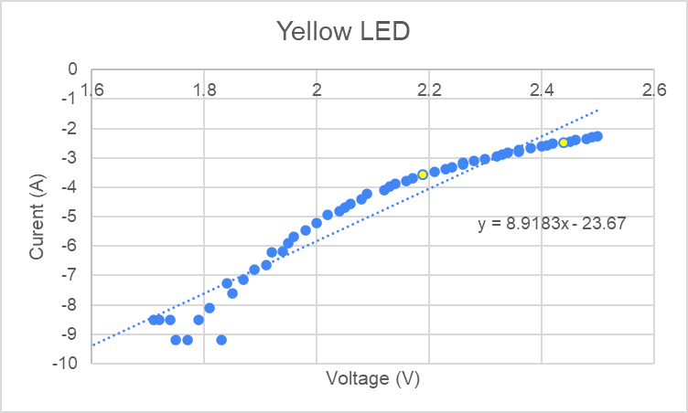

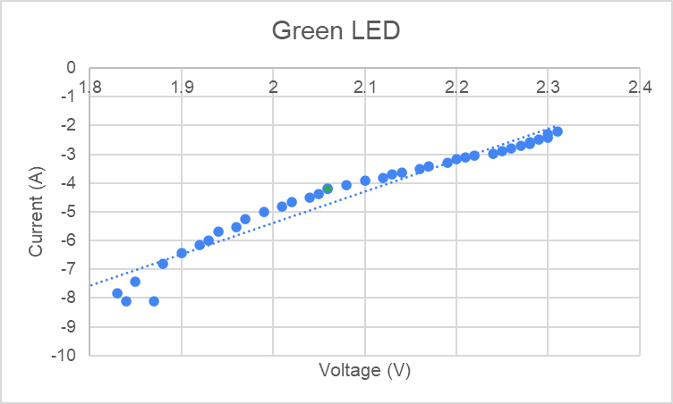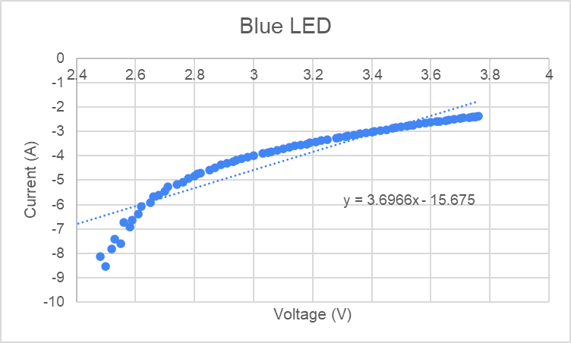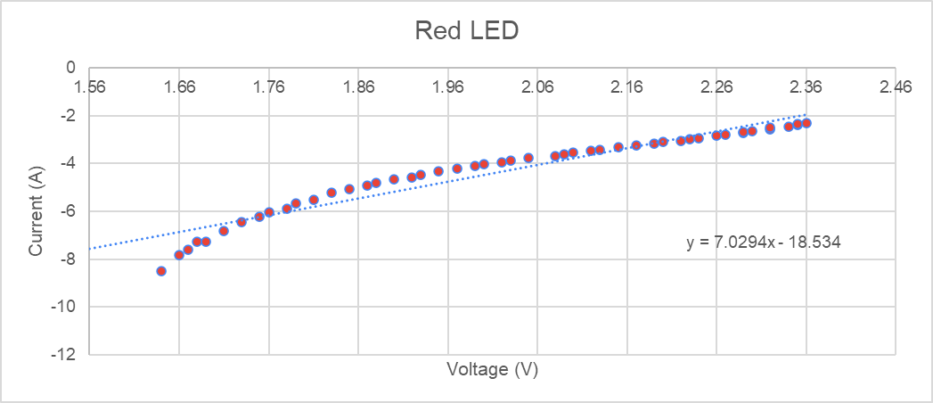

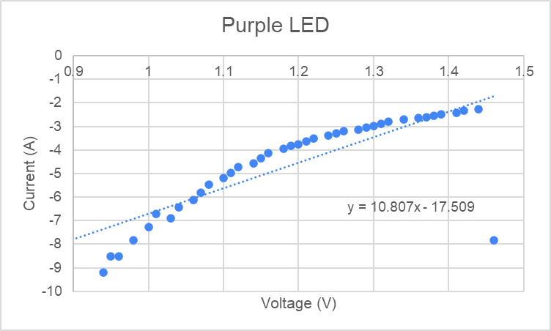

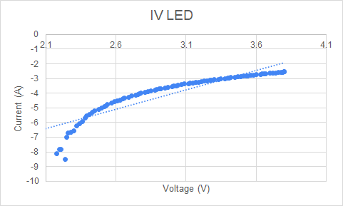

|  | Red | Yellow | Green | Blue | Purple | IR |
| --- | --- | --- | --- | --- | --- | --- |
| **“Turn on” V** | 1.64 | 1.71 | 1.83 | 2.48 | 0.95 | 2.18 |
| Uncertainty | ±0.005 V | | | | | |
| **Eg (V*e)** | 2.627x10-19 | 2.740x10-19 | 2.932x10-19 | 3.973x10-19 | 1.522x10-19 | 3.4931x10-19 |
| Uncertainty | ±0.05 *10^-19 eV | | | | | |
| **Wavelength** | 630 nm | 590 nm | 532 nm | 465 nm | 400 nm | 940 nm |
| Uncertainty | ±1 nm | | | | | |
| **F (Hz)** | 4.76x1014 | 5.08x1014 | 5.64x1014 | 6.45x1014 | 7.49x1014 | 3.19x1014 |
| Uncertainty | ±0.05*10^14 Hz | | | | | |

Purple and IR LED were eliminated as they deviated greatly from the general trend.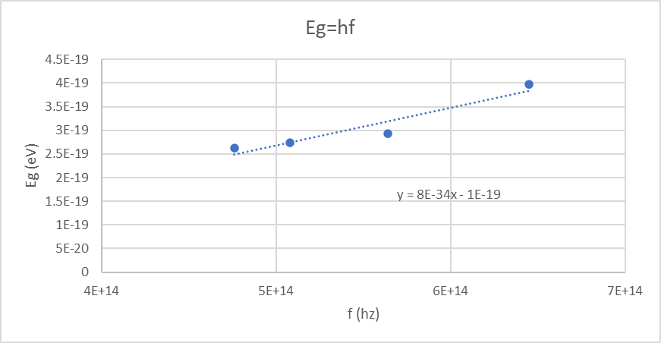

Planck’s constant can be found by rearranging the equation Eg=hf, where h becomes the slope of the graph. The slope in this graph is 8e-34 J/s. The accepted value of Planck’s constant is 6.64*10−34. Therefore, the percent error between the accepted value and experimental value is 20.48%.

## Discussion and Conclusions:

As stated earlier, the purple and IR LED values were eliminated from the Eg=hf graph as the values for both lights deviated greatly from the general trendline. The large deviation was likely the product of many factors, one such being the efficiency of the LED. Many LED lights were broken or extremely dim, which affected the data collected in this experiment.

**3**The break statement in the for loop allows exit out of a loop when an external condition is triggered. When the LEDs run at high voltages, they become extremely hot and cause damage to the LED lights or the soldering around them. The heat damage causes the LED light to dim, flicker, burn or die entirely. To put a break in the for loop, we prevent the voltage through the LED from exceeding the maximum current.

Appendix:

**4**// Call libraries required for external breakout boards and communications.

#include <Wire.h>

#include <SPI.h>

#include <Adafruit_MCP4725.h> // DAC library

#include <Adafruit_INA219.h> // INA219 current sensor library

// Declare a current sensor object.

Adafruit_INA219 ina219; // Commands like ina219.getCurrent_mA() will read the current.

// Declare our voltage supply objects.

Adafruit_MCP4725 dac_LEDsupply;

#define DAC_RESOLUTION (9) // Set this value to 9, 8, 7, 6 or 5 to adjust the resolution.

// Declare some useful variables.

float voltageAcrossLED;

float currentAcrossLED;

void setup(void) {

Serial.begin(9600); // Initiates serial communication, so we can send our data to

// our computer.

// Initialize the INA219 sensor (current sensor).

ina219.begin();

// Initialize our DAC breakout board.

dac_LEDsupply.begin(0x62); // 0x62 sets the hex address of dac

// so the arduino addresses the correct DAC.

}

void loop() {

for( int i = 0; i <=4095; i += 20 ){

**//** When i reaches more than 4095, it will stop. The voltage reaches about 5V, it will stop.

dac_LEDsupply.setVoltage(i,false);

**//** it will set the output voltage to the corresponding value of i in volts.

delay(10);

voltageAcrossLED = ina219.getBusVoltage_V(); //Take a voltage reading

Serial.print(voltageAcrossLED); //Print the voltage reading

Serial.print(" ") ;

currentAcrossLED = ina219.getCurrent_mA(); //Take a current reading

Serial.print(currentAcrossLED); //Print the current reading

Serial.println(" “);

if(currentAcrossLED>100){

i = 4097;

break; //when the i exceeds 4097, it allows to terminate and exit a loop

}

// Turn off the LED voltage supply.

delay(30); // Let the system cool

}

**Reference**

1. *2N3904 - NPN Transistor*. (n.d.). Components101. https://components101.com/transistors/2n3904-pinout-datasheet

2. Physics for Scientists and Engineers with Modern Physics”, by Raymond A. Serway and Jewett, Jr., 10th edition, Thomson, Inc.

3. *TIP41C Transistor Pinout, Equivalent, Specs, Datasheet & More*. (2021, October 6). Components Info. https://www.componentsinfo.com/tip41c-transistor-pinout-equivalent/